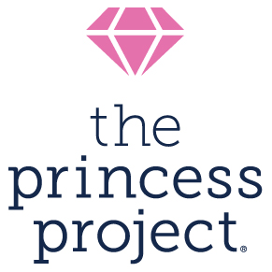

Receipt for Donation of Goods

The Princess Project is a nonprofit organization that provides free prom dresses and accessories to teens who would otherwise be unable to attend their event. Founded in 2002, The Princess Project serves more than 5,000 teens each prom season at five locations across California. Our effort is made possible through invaluable contributions from volunteers, community members, and donors like you. Thank you for your support!

Date of Donation:

Donor Name:
Donor Address:

Description of Donated Item | Estimated Value

Total donation amount: __________________

The Princess Project is recognized as a tax-exempt public charity under Section 501(c)(3) of the internal Revenue Code. Our tax ID number is 20-1392257.

This form is your receipt. No other receipt will be issued, and you do not have to send a copy to The Princess Project. Retain this receipt and refer to IRS Publication 526 or consult your tax advisor for assistance determining what, if any, portion of your donation may be tax deductible.

Donors receive no goods or services in exchange for donating the items listed on this receipt. Donations are deductible to the extent allowed by law.
The Princess Project
P.O. Box 471045, San Francisco, CA 94147-1045
www.princessproject.org, info@princessproject.org

